A000-AM,S-Argentina-Tucumán Province-Projectile Points-Obsidian-6000-2000 BCE

* 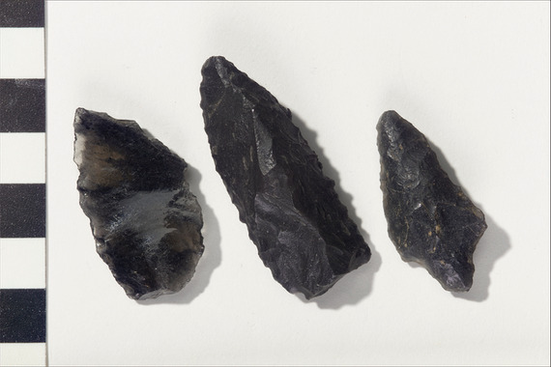
* **Case No. Projectile Points**
* **Culture/People:**

probably Intihuasi Tradition (archaeological culture) (attributed)

* **Object name:**

Bifacial tool/projectile point

* **Date created:**

6000-2000 BCE

* **Place:**

Tafí del Valle Department; Tucumán Province; Argentina

* **Media/Materials:**

Stone

* **Techniques:**

Flaked/chipped

* **Collection History/Provenance:**

Collection history unknown, but possibly collected or excavated by archaeologist and entomologist Dr. Carlos Bruch (1869-1943); formerly in the collection of the Field Museum of Natural History (Chicago, Illinois); acquired by MAI via an exchange with the Field Museum in 1918.

* **Catalog number:**

8/7072



This item is currently on view at NMAI, DC.